**Hot Spinach and Artichoke Dip**

**Ingredients**

nocoupons

* ½ cup thawed, chopped frozen [spinach](http://www.foodterms.com/encyclopedia/spinach/index.html)
* ½ cup thawed, chopped frozen [artichoke](http://www.foodterms.com/encyclopedia/artichoke/index.html) hearts
* 3 ounces cream cheese
* 2 tbsp. [sour cream](http://www.foodterms.com/encyclopedia/sour-cream/index.html)
* 2 tbsp. [mayonnaise](http://www.foodterms.com/encyclopedia/mayonnaise/index.html)
* 3 tbsp. grated [Parmesan](http://www.foodterms.com/encyclopedia/parmesan/index.html)
* 1/4 teaspoon red pepper flakes
* 1/8 (pinch) teaspoon salt
* 1/4 teaspoon minced garlic
* ¼ cup shredded mozzarella

**Directions**

1. Preheat broiler.
2. Measure thawed spinach and artichokes into a clean kitchen towel. Ring out liquid over sink. Liquid may be hot- be careful not to burn your hands!
3. Heat [cream cheese](http://www.foodterms.com/encyclopedia/cream-cheese/index.html) in microwave safe bowl for 1 minute or until hot and soft.
4. Stir spinach and artichokes into cream cheese. Mix in sour cream, mayonnaise, parmesan, red pepper flakes, salt, and garlic.
5. Stir well to combine. Put mixture into baking dish. Top with mozzarella.
6. Broil for 3-5 minutes or until cheese is melted and dip is hot and bubbly.
7. Enjoy with Tortilla chips ☺

[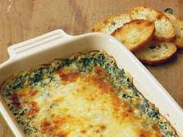](http://www.google.com/imgres?imgurl=http://www.foodpeoplewant.com/wp-content/uploads/2010/03/Hot-Spinach-Dip1.jpg&imgrefurl=http://www.foodpeoplewant.com/hot-spinach-dip/&usg=__qreDHqx6oxrd58-VunAyiDXY9VY=&h=2304&w=3072&sz=5639&hl=en&start=70&zoom=1&tbnid=oglpvjwV9GkCyM:&tbnh=154&tbnw=201&prev=/images?q=spinach+dip&hl=en&safe=active&biw=1276&bih=815&gbv=2&tbs=isch:1&itbs=1&ei=QxDTTPPWIoTWngey74DkDw&iact=hc&vpx=156&vpy=449&dur=235&hovh=167&hovw=223&tx=139&ty=90&oei=kQ_TTMeZMMyOnwe8lez1Dw&esq=4&page=4&ndsp=24&ved=1t:429,r:12,s:70)

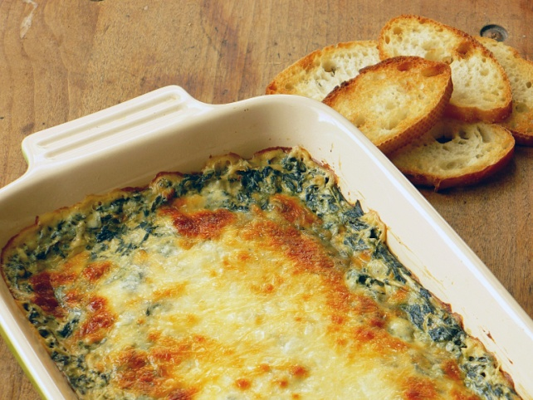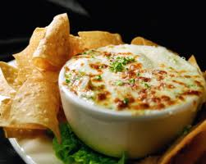[](http://www.google.com/imgres?imgurl=http://www.harleyseye.com/images/Spinach_Dip.jpg&imgrefurl=http://www.harleyseye.com/food_wine_photo_12.html&usg=__b_pHrYZIdf9MKF1P81uJDg4QoVs=&h=319&w=400&sz=131&hl=en&start=0&zoom=1&tbnid=JOFKnSSGhi3N1M:&tbnh=143&tbnw=173&prev=/images?q=spinach+dip&hl=en&safe=active&biw=1276&bih=815&gbv=2&tbs=isch:1&itbs=1&iact=hc&vpx=128&vpy=284&dur=234&hovh=200&hovw=251&tx=145&ty=103&ei=kQ_TTMeZMMyOnwe8lez1Dw&oei=kQ_TTMeZMMyOnwe8lez1Dw&esq=1&page=1&ndsp=25&ved=1t:429,r:12,s:0)[](http://www.google.com/imgres?imgurl=http://www.harleyseye.com/images/Spinach_Dip.jpg&imgrefurl=http://www.harleyseye.com/food_wine_photo_12.html&usg=__b_pHrYZIdf9MKF1P81uJDg4QoVs=&h=319&w=400&sz=131&hl=en&start=0&zoom=1&tbnid=JOFKnSSGhi3N1M:&tbnh=143&tbnw=173&prev=/images?q=spinach+dip&hl=en&safe=active&biw=1276&bih=815&gbv=2&tbs=isch:1&itbs=1&iact=hc&vpx=128&vpy=350&dur=15&hovh=200&hovw=251&tx=150&ty=99&ei=kQ_TTMeZMMyOnwe8lez1Dw&oei=kQ_TTMeZMMyOnwe8lez1Dw&esq=1&page=1&ndsp=25&ved=1t:429,r:12,s:0)